**Data Format**  
  
Each instance file has the following format:  
- *row 1*: number_of_stacks (m)      number_of_blocks (n)  
- *each row from 2 to n+1*: total number of blocks on the stack (h) and list of blocks from bottom to top  
  
**Example**: Consider instance *"data3-3-1.dat"*. The input bay is the following:

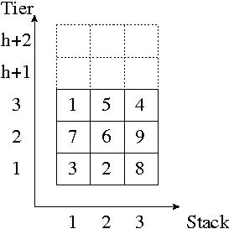

Tiers "h+1" and "h+2" are empty tiers that are used to relocate blocks during the retrieval operation. Throughout the computational experiment we kept the buffer area fixed to "h+2", *i.e.*, two empty tiers are used to relocate blocks.